ITE Hong Kong 2024 – 38th ITE (Leisure) & 19th ITE MICE
13 – 16 June 2024, Hong Kong Convention & Exhibition Centre (Halls 1)
SPACE APPLICATION FORM
1. COMPANY INFORMATION
Company Name:
Address:
City: |  | Country / Region:
Tel: | - - | Fax: | - -
E-mail: |  | Website:
Contact Person : |  | Job Title:
2. BILING INFORMATION (If different from the above)
Company Name:
Address:
City: |  | Country / Region:
Tel: | - - | Fax: | - -
E-mail: |  | Website:
Contact Person : |  | Job Title:

Package Options | Price per sqm  (1-side open) | Total Area | Frontage Surcharge |  |  | Rental Amount
 |  |  | 2-side open | 3-side open | 4-side open
Shell Standard A | US$500 (min. 9sqm  i.e. 3m x 3m)  m x m | = sqm | x 1.05 | x 1.075 | x 1.1 | US$
Shell Standard B | US$520 (min. 9sqm  i.e. 3m x 3m)  m x m | = sqm | x 1.05 | x 1.075 | x 1.1 | US$
Shell Corner Upgrade | US$570 (min. 18sqm  i.e. 3m x 6m)  m x m | = sqm | Included | x 1.025 | x 1.05 | US$
Raw Space | US$460 (min. 18sqm  i..e. 3m x 6m)  m x m | = sqm | x 1.05 | x 1.075 | x 1.1 | US$
For the layout / booth facilities, please refer to page 2. Sub-total: |  |  |  |  |  | US$
TKS, the organizer reserves the final right to reject any applications that are of inappropriate content.
Signature: |  | Stamp:
Name in Print: |  | Date:

Booth Layout | Facilities
Raw Space at US$460 / SQM* | Min. 18SQM  * Subject to Surcharge: 2-side open +5%; 3-side open +7.5%; 4-side open +10%
Shell Standard A at US$500 / SQM  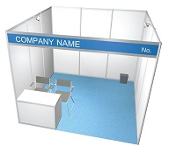  Shell Standard B at US$520 / SQM  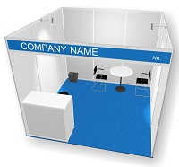 | Shell Standard A: 9sqm x US$500 = US$4,500*  - Space with white system panels & blue carpet  - Fascia board with company name & booth no.  - (1) lockable cabinet  - (2) spotlights (23W)  - (2) leather chairs  - (1) waste paper basket  Shell Standard B: 9sqm x US$520 = US$4,680*  - Space with white system panels & blue carpet  - Fascia board with company name & booth no.  - (1) information counter with lockable cabinet (1000mmH) & (1) 1 bar stool  - (2) spotlights (23W)  - (2) leather chairs  - (1) round table  - (1) 3-pin plug (500W)  - (1) waste paper basket  * Subject to Surcharge:  2-side open +5%; 3-side open +7.5%; 4-side open +10%
Shell Corner Upgrade at US$570 /SQM  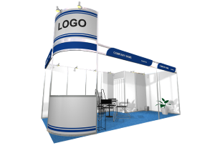  ^Color carpet selection: Blue/Orange/Green/Red/Yellow | Minimum 18sqm x US$570 = US$10,260 (2-side open) each additional side + 2.5% frontage surcharge  - Space with white partitions / fascia / carpet^  - (1) corporate tower with built-in information counter  - (2) company names, (1) logo by sticker cutout  - Store room (2m x 1m) with lockable folding door  - (1) round table, (1) catalogue holder  - (4) leather chairs, (1) black bar stool  - (2) waste paper basket  - (1) potted plant  - (6) longarm spotlights (23W)  - (2) spotlights (23W)  - (1) 3-pin plug (500W)
Additional space in multiple of 3SQM in booking Shell Standard A/B/Corner Upgrade will provide:
  - 1 extra spot light (23W)
  - 1 extra leather chair
For details of our services, advertising & sponsorship package, please contact us or visit www.itehk.com.
Organizer  TKS Exhibition Services Ltd | Address:  Rooms 2301-04, 23/F, Hang Seng North Point Building, 341 King's Road, North Point, Hong Kong  Tel: (852) 3155 0600  Email: travel@tkshk.com

